Task: Kafka Implementation

Submitted by:
Kashan Zulfiqar

Dated : 03/11/2026
- Kafka
It’s a event streaming platform.It stores events that are pushed from the producer for a specific retention period after that the events are deleted even if the consumer has not pulled.
It stores events in topics as there can be many services that are producing and pushing events to the kafka store so according to the service events are stored topic wise consumer pulls the events from these topics.
Kafka breaks topics into smaller pieces called Partitions and spreads those pieces across all the brokers.

- Use case:-
Kafka sits at the middle of the services (between producer and consumer) producer pushes the events to the kafka topic and donot waits for the response starts working on other events rest is handled by kafka.
The consumer on the other side pulls the events and process them when ever they are ready this reduces the down time and prevents data loss.

- Installation:-
First step we create a saparate namespace for kafka pod



- Deployment :-
Launching kafka as deployment with persistant volume attaches so logs remain saved after restart.
Also made a cluster ip service to point to kibana so every time the pod in which kibana is running restarts the connection is not lost.

- Kafka Deployment.yaml
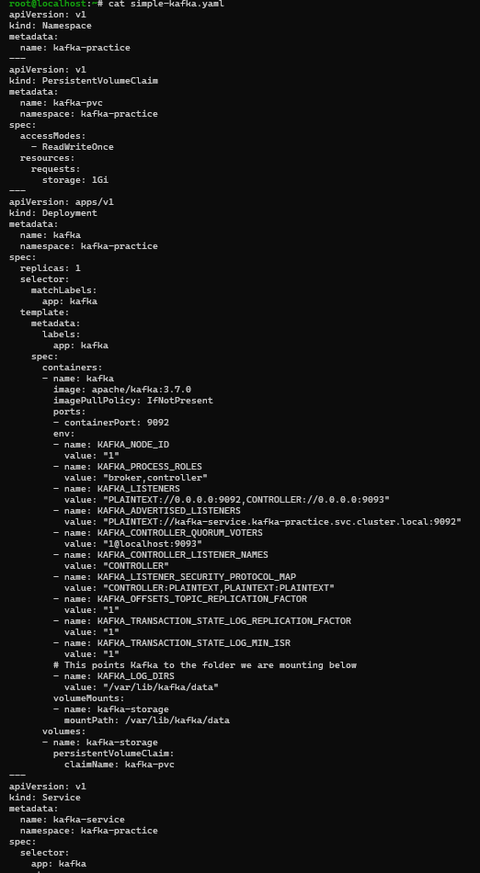

- Now kafka pod is in running state


- Producer (a micro service that pushes events or logs to kafka is a producer)
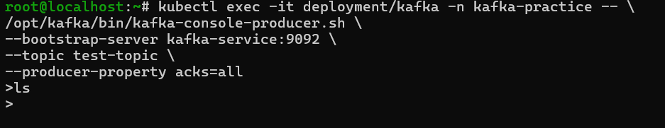

- Cosumer (a micro servicee that consumes the eevents or logs is a consumer)
